超声仿真软件使用过程简介

## 一 看实例囊肿超声程序使用

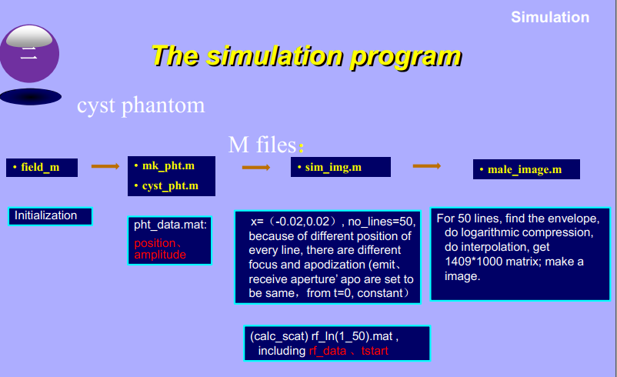

**注：cyst_pht.m不需要运行**

生成图像

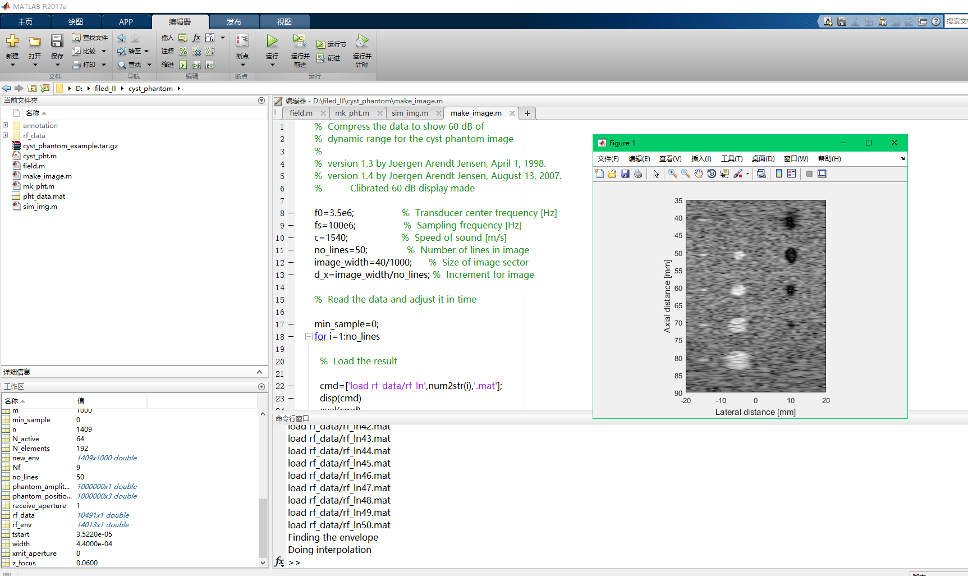

## 一 超声原理

### 1.1 超声分类

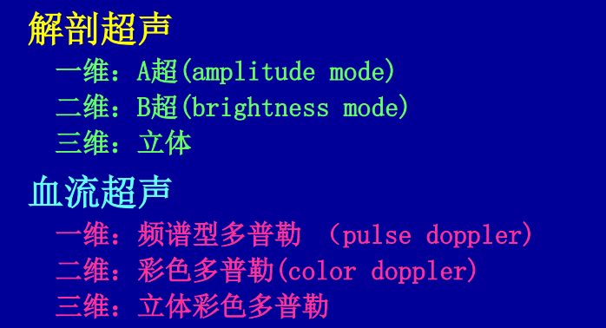

### 1.2 超声原理

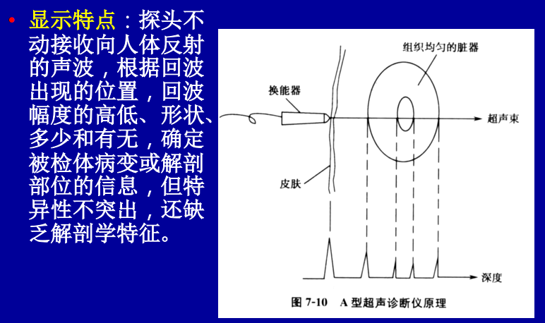

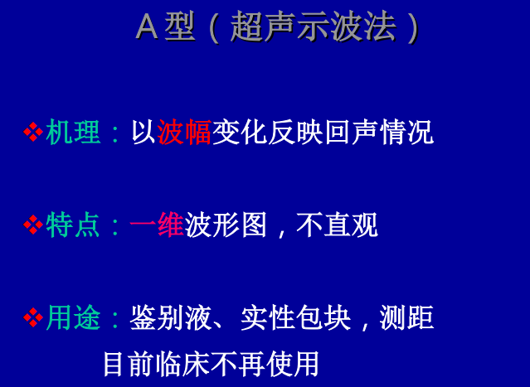

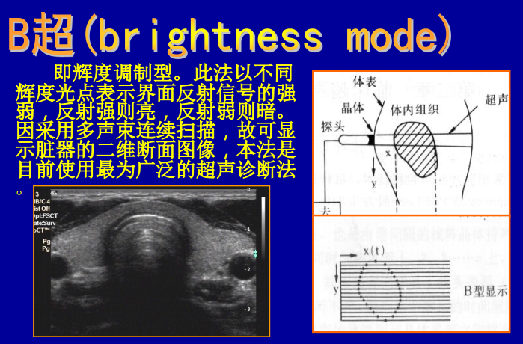

## 二 field_II基本命令

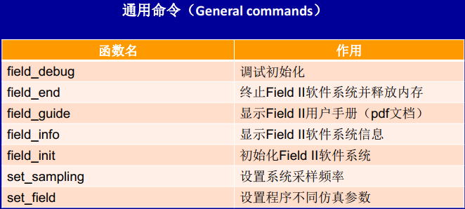

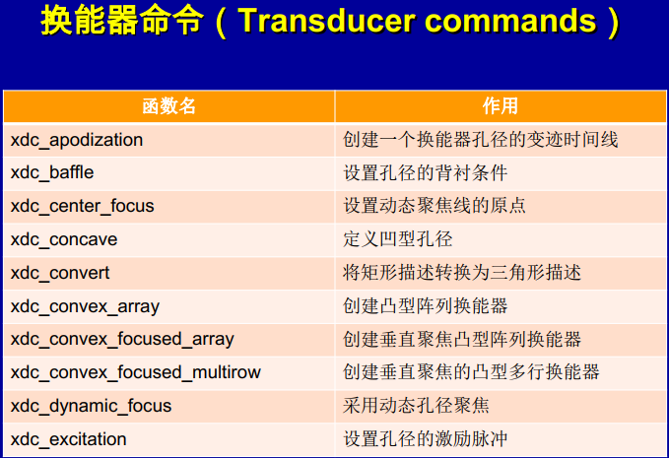

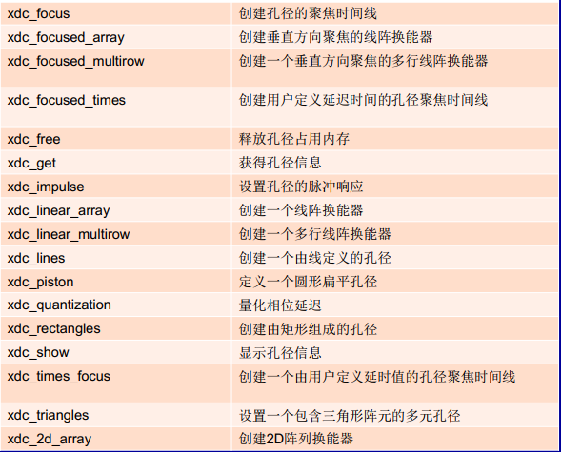

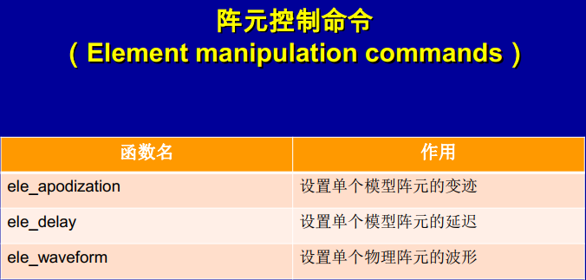

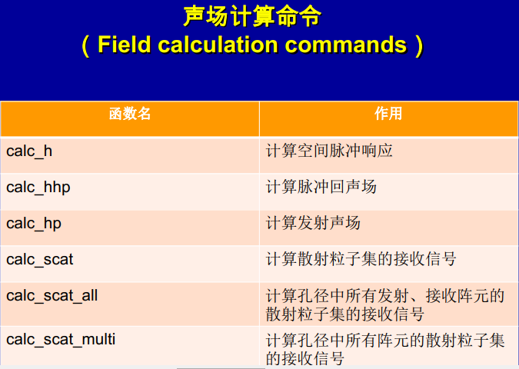

## 二 囊肿程序一步步注解

### field.m

path(path, 'D:\研一上学期课件\医学超声\Field_II_PC7')

field_init

### cyst_pht.m囊肿函数

% Create a computer model of a cyst phantom. The phantom contains

% fiven point targets and 6, 5, 4, 3, 2 mm diameter waterfilled cysts,

% and 6, 5, 4, 3, 2 mm diameter high scattering regions. All scatterers

% are situated in a box of (x,y,z)=(50,10,60) mm and the box starts

% 30 mm from the transducer surface.

%构建一个计算机囊肿仿真模型 在一个（x,y,z）=（50，10，60）mm矩形框内，分别放置5个点目标

%直径为6，5，4，3, 2mm液性囊肿 以及直径为6,5,4,3,2mm高回声囊肿 探头表面从30mm开始

% Calling: [positions, amp] = cyst_phantom (N);

% Parameters: N - Number of scatterers in the phantom

% Output: positions - Positions of the scatterers.

% amp- amplitude of the scatterers.

% Version 2.2, April 2, 1998 by Joergen Arendt Jensen

function [positions, amp] = cyst_phantom (N)

x_size = 50/1000; % Width of phantom [mm]

y_size = 10/1000; % Transverse width of phantom [mm]

z_size = 60/1000; % Height of phantom [mm]

z_start = 30/1000; % Start of phantom surface [mm];

% Create the general scatterers

x = (rand (N,1)-0.5)*x_size;

y = (rand (N,1)-0.5)*y_size;

z = rand (N,1)*z_size + z_start;

% Generate the amplitudes with a Gaussian distribution

amp=randn(N,1);

% Make the cyst and set the amplitudes to zero inside

% 6 mm cyst

r=6/2/1000; % Radius of cyst [mm]

xc=10/1000; % Place of cyst [mm]

zc=10/1000+z_start;

inside = ( ((x-xc).^2 + (z-zc).^2) < r^2);

%之所以这么设置参数（不用设置yc）和B超扫描方式是一一对应的

%amp = amp .* (1-inside);

% 5 mm cyst

r=5/2/1000; % Radius of cyst [mm]

zc=20/1000+z_start;

inside = ( ((x-xc).^2 + (z-zc).^2) < r^2);

amp = amp .* (1-inside);

% 4 mm cyst

r=4/2/1000; % Radius of cyst [mm]

zc=30/1000+z_start;

inside = ( ((x-xc).^2 + (z-zc).^2) < r^2);

amp = amp .* (1-inside);

% 3 mm cyst

r=3/2/1000; % Radius of cyst [mm]

zc=40/1000+z_start;

inside = ( ((x-xc).^2 + (z-zc).^2) < r^2);

amp = amp .* (1-inside);

% 2 mm cyst

r=2/2/1000; % Radius of cyst [mm]

zc=50/1000+z_start;

inside = ( ((x-xc).^2 + (z-zc).^2) < r^2);

amp = amp .* (1-inside);

% Make the high scattering region and set the amplitudes to 10 times inside

% 6 mm region

r=5/2/1000; % Radius of cyst [mm]

xc=-5/1000; % Place of cyst [mm]

zc=50/1000+z_start;

inside = ( ((x-xc).^2 + (z-zc).^2) < r^2) ;

amp = amp .* (1-inside) + 10*amp .* inside;

%可以理解的是为什么amp加上10*amp*inside（因为是实性囊肿 所以反射弧度更大） 但是值得好奇的是

%为什么是乘inside

% 5 mm region

r=4/2/1000; % Radius of cyst [mm]

zc=40/1000+z_start;

inside = ( ((x-xc).^2 + (z-zc).^2) < r^2) ;

amp = amp .* (1-inside) + 10*amp .* inside;

% 4 mm region

r=3/2/1000; % Radius of cyst [mm]

zc=30/1000+z_start;

inside = ( ((x-xc).^2 + (z-zc).^2) < r^2) ;

amp = amp .* (1-inside) + 10*amp .* inside;

% 3 mm region

r=2/2/1000; % Radius of cyst [mm]

zc=20/1000+z_start;

inside = ( ((x-xc).^2 + (z-zc).^2) < r^2) ;

amp = amp .* (1-inside) + 10*amp .* inside;

% 2 mm region

r=1/2/1000; % Radius of cyst [mm]

zc=10/1000+z_start;

inside = ( ((x-xc).^2 + (z-zc).^2) < r^2) ;

amp = amp .* (1-inside) + 10*amp .* inside;

% Place the point scatterers in the phantom

for i=N-5:N

x(i) = -15/1000;

y(i) = 0;

z(i) = z_start + (10+5*10)/1000 + (i-N)*10/1000;

amp(i) = 20;

%就是不知道这个是什么意思 为什么是这样写

end

% Return the variables

positions=[x y z];

### mk_pht.m

% Make the scatteres for a simulation and store

% it in a file for later simulation use

% Joergen Arendt Jensen, Feb. 26, 1997

[phantom_positions, phantom_amplitudes] = cyst_pht(100000);

save pht_data.mat phantom_positions phantom_amplitudes

### sim_img.m

% Example of use of the new Field II program running under

% Matlab.

%

% This example shows how a linear array B-mode system scans an image

%B超扫描图像

% This script assumes that the field_init procedure has been called

% Here the field simulation is performed and the data is stored

% in rf-files; one for each rf-line done. The data must then

% subsequently be processed to **yield** the image. The data for the

% scatteres are read from the file pht_data.mat, so that the procedure

% can be started again or run for a number of workstations.

%

% Example by Joergen Arendt Jensen and Peter Munk,

% Version 1.2, August 14, 1998, JAJ.

% Ver. 1.1: 1/4-98: Procedure xdc_focus_center inserted to use the new

% focusing scheme for the Field II program

% Ver. 2.0: 13/8 2007: Parallel version that checks whether the simulation

% of a line has been made before, which makes it possible

% to run the code in parallel on multiple workstations.

% Generate the transducer apertures for send and receive

f0=3.5e6; % Transducer center frequency [Hz]

fs=100e6; % Sampling frequency [Hz]

%接收信号的采样

c=1540; % Speed of sound [m/s]

lambda=c/f0; % Wavelength [m]

%发射波长

width=lambda; % Width of element

element_height=5/1000; % Height of element [m]

%为什么单位高是这个值 还有就是为什么要设置单位高

kerf=0.05/1000; % Kerf [m]

%Distance in x-direction between elements

focus=[0 0 70]/1000; % Fixed focal point [m]

N_elements=192; % Number of physical elements

N_active=64; % Number of active elements

% Set the sampling frequency

set_sampling(fs);

% Generate aperture for emission

%创建一个线阵列换能器

xmit_aperture = xdc_linear_array (N_elements, width, element_height, kerf, 1, 10,focus);

% Set the impulse response and excitation of the xmit aperture

impulse_response=sin(2*pi*f0*(0:1/fs:2/f0));

impulse_response=impulse_response.*hanning(max(size(impulse_response)))';

%设置孔径脉冲响应

xdc_impulse (xmit_aperture, impulse_response);

excitation=sin(2*pi*f0*(0:1/fs:2/f0));

%设置孔径的激励脉冲

xdc_excitation (xmit_aperture, excitation);

% Generate aperture for reception

receive_aperture = xdc_linear_array (N_elements, width, element_height, kerf, 1, 10,focus);

% Set the impulse response for the receive aperture

xdc_impulse (receive_aperture, impulse_response);

% Load the computer phantom

if ~exist('pht_data.mat')

disp('Scatterer positions should be made by the script mk_pht')

disp('before this script can be run')

return

else

load pht_data

end

% Set the different focal zones for reception

focal_zones=[30:20:200]'/1000;

Nf=max(size(focal_zones));

focus_times=(focal_zones-10/1000)/1540;

z_focus=60/1000; % Transmit focus

% Set the apodization

apo=hanning(N_active)';

% Do linear array imaging

no_lines=50; % Number of lines in image

image_width=40/1000; % Size of image sector

d_x=image_width/no_lines; % Increment for image

% Do imaging line by line

for i=[1:no_lines]

% Test if the file for the line exist.

% Skip the simulation, if the line exits and

% go the next line. Else make the simulation

file_name=['rf_data/rf_ln',num2str(i),'.mat'];

if ~exist(file_name)

% Save a file to reserve the calculation

cmd=['save rf_data/rf_ln',num2str(i),'.mat i'];

eval(cmd);

disp(['Now making line ',num2str(i)])

% The the imaging direction

x= -image_width/2 +(i-1)*d_x;

% Set the focus for this direction with the proper reference point

%设置动态聚焦线原点

xdc_center_focus (xmit_aperture, [x 0 0]);

%创建孔径聚焦时间线

xdc_focus (xmit_aperture, 0, [x 0 z_focus]);

%设置动态聚焦线原点

xdc_center_focus (receive_aperture, [x 0 0]);

xdc_focus (receive_aperture, focus_times, [x*ones(Nf,1), zeros(Nf,1), focal_zones]);

% Calculate the apodization

N_pre = round(x/(width+kerf) + N_elements/2 - N_active/2);

N_post = N_elements - N_pre - N_active;

apo_vector=[zeros(1,N_pre) apo zeros(1,N_post)];

xdc_apodization (xmit_aperture, 0, apo_vector);

xdc_apodization (receive_aperture, 0, apo_vector);

% Calculate the received response

[rf_data, tstart]=calc_scat(xmit_aperture, receive_aperture, phantom_positions, phantom_amplitudes);

% Store the result

cmd=['save rf_data/rf_ln',num2str(i),'.mat rf_data tstart'];

disp(cmd)

eval(cmd);

else

disp(['Line ',num2str(i),' is being made by another machine.'])

end

end

% Free space for apertures

xdc_free (xmit_aperture)

xdc_free (receive_aperture)

disp('You should now run make_image to display the image')

### make_image

% Compress the data to show 60 dB of

% dynamic range for the cyst phantom image

%

% version 1.3 by Joergen Arendt Jensen, April 1, 1998.

% version 1.4 by Joergen Arendt Jensen, August 13, 2007.

% Clibrated 60 dB display made

f0=3.5e6; % Transducer center frequency [Hz]

fs=100e6; % Sampling frequency [Hz]

c=1540; % Speed of sound [m/s]

no_lines=50; % Number of lines in image

image_width=40/1000; % Size of image sector

d_x=image_width/no_lines; % Increment for image

% Read the data and adjust it in time

min_sample=0;

for i=1:no_lines

% Load the result

cmd=['load rf_data/rf_ln',num2str(i),'.mat'];

disp(cmd)

eval(cmd)

% Find the envelope

rf_env=abs(hilbert([zeros(round(tstart*fs-min_sample),1); rf_data]));

env(1:max(size(rf_env)),i)=rf_env;

end

% Do logarithmic compression

D=10; % Sampling frequency decimation factor

disp('Finding the envelope')

log_env=env(1:D:max(size(env)),:)/max(max(env));

log_env=20*log10(log_env);

log_env=127/60*(log_env+60);

% Make an interpolated image

disp('Doing interpolation')

ID=20;

[n,m]=size(log_env);

new_env=zeros(n,m*ID);

for i=1:n

new_env(i,:)=abs(interp(log_env(i,:),ID));

end

[n,m]=size(new_env);

fn=fs/D;

clf

image(((1:(ID*no_lines-1))*d_x/ID-no_lines*d_x/2)*1000,((1:n)/fn+min_sample/fs)*1540/2*1000,new_env)

xlabel('Lateral distance [mm]')

ylabel('Axial distance [mm]')

colormap(gray(127))

axis('image')

axis([-20 20 35 90])

## 出现问题及解决方案

### 1 中文显示方块

